

American International University-Bangladesh (AIUB)
Department of Computer Science
Faculty of Science & Technology (FST)
Real-Time Tracking and Automated Fare Management System
A Software Requirement Engineering Project Submitted
By
Semester: Spring_24_25 |  | Section: | Group Number:
SN | Student Name | Student ID | Contribution in %  (100%) | Individual  Marks
 | MASUDUR RAHMAN | 23-50797-1 | 100%

The project will be Evaluated for the following Course Outcomes

EVALUATION CRITERIA | Total Marks (50)
 | 40
Introduction [Section 1.1-1.4], Format, Submission, Defense | [10 Marks]
System Overall Description & Functional Requirements | [10 Marks]
System Quality Attributes and Project Requirements | [10 Marks]
UML and E-R Diagram with Data Dictionary | [10 Marks]
UI/UX Prototyping | [10 Marks]

1. Introduction

1.1 Purpose
This Software Requirements Specification (SRS) document provides a comprehensive and detailed description of the Smart Bus Tracking and Fare Management System. It defines both functional requirements (FR) and non-functional requirements (NFR) of the system to guide developers, testers, and stakeholders throughout the development lifecycle.
The main purpose of this system is to modernize traditional public transportation by integrating digital technologies that enhance efficiency, accuracy, and user convenience.
The system aims to:
- Provide real-time bus tracking so passengers can monitor bus locations and arrival times
- Automate fare calculation and digital payment, reducing manual errors
- Improve passenger convenience through easy access to transport services
- Enhance transport system efficiency by reducing delays and improving route management
- Ensure transparency and accountability in fare management

Scope
This SRS document covers the complete functionality and behavior of the system, including all major modules and user interactions.
The system includes:
User Authentication System
  - Registration, login, logout
  - Role-based access (Admin, Driver, Passenger)
Bus Tracking System
  - GPS-based real-time location tracking
  - Estimated arrival time (ETA) calculation
Seat Reservation System
  - Seat availability checking
  - Booking and cancellation features
Payment System
  - Digital fare calculation
  - Multiple payment methods (mobile banking, cards, etc.)
Feedback and Complaint System
  - User feedback submission
  - Complaint tracking and resolution

Business Requirements
The system is designed to achieve the following business goals:
- Improve public transport reliability by providing accurate tracking information
- Reduce traffic congestion by encouraging public transport usage
- Increase passenger satisfaction through better service and convenience
- Ensure a transparent and fair fare system
- Support data-driven decision-making for transport authorities

1.2 Document Conventions
The following conventions are used throughout this document:
- Bold Text → Represents important features or key concepts
- Italic Text → Represents optional features or enhancements
- FR (Functional Requirement) → Defines what the system should do
- NFR (Non-Functional Requirement) → Defines system performance and quality attributes

Priority Levels:
- High → Critical for system operation
- Medium → Important but not critical
- Low → Optional or future enhancement
Each requirement is assigned a priority level based on its importance.

1.3 Intended Audience and Reading Suggestions

Intended Audience
This Software Requirements Specification (SRS) document is intended for multiple stakeholders who are directly or indirectly involved in the development, implementation, and use of the Smart Bus Tracking and Fare Management System.

Developers
Developers are responsible for designing and implementing the system.
They should focus on:
- System architecture and overall structure
- Functional Requirements (FRs) for each module
- Integration of components such as GPS tracking, payment system, and database
- Implementation details of core features like login, registration, and tracking
Their main goal is to understand how the system should be built and how different modules interact with each other.

Testers
Testers are responsible for ensuring the system works correctly according to requirements.
They should focus on:
- Functional Requirements (FRs) to verify system behavior
- Non-Functional Requirements (NFRs) such as performance, security, and reliability
- Test cases for login, booking, payment, and tracking features
- Validation of system outputs against expected results
Their main goal is to ensure the system is error-free, reliable, and meets all specified requirements.

Project Managers
Project Managers are responsible for planning, monitoring, and controlling the project.
They should focus on:
- Overall system scope and objectives
- Business requirements and project goals
- Priority levels of requirements (High, Medium, Low)
- Resource allocation, timeline, and budget planning
Their main goal is to ensure the project is completed on time, within budget, and meets business objectives.

End Users (Passengers, Drivers, Admins)
End users are the actual users of the system, including passengers, drivers, and administrators.
They should focus on:
- System features such as registration, login, and bus tracking
- Ease of use and user interface design
- Seat reservation and payment functionality
- Feedback, rating, and complaint system
Their main goal is to understand how to use the system effectively for daily transportation needs and management tasks.

1.4 References
- IEEE 830 Software Requirements Specification Standard
- Software Engineering by Roger Pressman
- Google Maps API Documentation
- GDPR (General Data Protection Regulation)
- WCAG 2.1 Accessibility Guidelines

2. Overall Description

2.1 Product Perspective

Background Problem
Public transportation systems in Bangladesh, especially in urban areas like Dhaka, face several critical challenges that reduce efficiency and passenger satisfaction. These include:
- Severe Traffic Congestion: Heavy traffic causes delays in bus schedules, making travel time unpredictable.
- Unreliable Bus Schedules: Due to poor planning and lack of monitoring, buses do not follow fixed schedules.
- Lack of Real-Time Information: Passengers cannot track bus locations or estimated arrival times, leading to long waiting periods and uncertainty.
- Manual and Inefficient Fare Collection: Traditional fare systems rely on cash and paper tickets, which are slow, error-prone, and susceptible to fraud.
These problems create inconvenience for passengers, reduce trust in public transport, and encourage the use of private vehicles, which further increases traffic congestion and pollution.

Product Origin
The proposed Smart Bus Tracking and Fare Management System is a new standalone application developed to address the limitations of traditional transportation systems.
It replaces manual processes with a digital, automated, and intelligent system that improves efficiency, transparency, and user convenience. The system leverages modern technologies such as GPS, mobile applications, and online payment systems.

System Context
The system operates within a connected digital environment and integrates multiple components:
- GPS Devices: Installed in buses to provide real-time location data
- Mobile and Web Applications: Allow passengers to access tracking, booking, and payment services
- Payment Gateways: Enable secure digital transactions through services like bKash, Nagad, and Rocket
- Cloud Servers: Store and process data, ensuring scalability and real-time updates
- Database Systems: Manage user data, routes, bookings, and transactions
- This integration ensures smooth communication between users, buses, and system administrators.

Business Objectives
The main business objectives of the system are:
- Improve overall transportation efficiency
- Reduce operational and administrative costs
- Increase passenger trust through transparency and reliability
- Enable data-driven decision making for transport authorities
- Enhance user experience and satisfaction
- Support the growth of smart city infrastructure

2.2 Product Functions
The Smart Bus Tracking and Fare Management System provides the following major functions:

1. User Registration & Login
- Users can create accounts by providing personal information
- Secure login using username and password
- Authentication through database verification

2. Real-Time GPS-Based Bus Tracking
- Displays live bus location on map
- Uses GPS data for accurate tracking
- Helps users estimate arrival time

3. Route and Stop Information
- Shows detailed bus routes
- Displays all stoppages and transit points
- Provides estimated arrival times for each stop

4. Bus Search System
- Users can search buses by source and destination
- Displays available buses and routes
- Shows fare information

5. Seat Reservation System
- Allows users to reserve seats in advance
- Users can select pickup points
- Displays available seats and booking details

6. Automated Fare Calculation
- Calculates fare based on distance or predefined rules
- Ensures accurate and transparent pricing
- Reduces human error and fraud

7. Digital Payment System
- Supports mobile banking (bKash, Nagad, Rocket)
- Provides secure payment processing
- Generates digital receipts

8. Feedback, Rating & Complaint Management
- Users can provide feedback on services
- Rating system for buses and services
- Complaint submission for issues and improvements

2.3 User Classes and Characteristics
User Class | Description | Skill Level
Passenger | Uses app for tracking, booking, payment | Basic
Driver | Views passenger pickup points | Medium
Bus Company | Manages buses and schedules | Advanced
Admin | Full system control | Expert

Most Important User:
Passenger (Primary user of the system)

2.4 Hardware and Operating Environment

Hardware:
- Smartphone (Android/iOS)
- Server system
- GPS devices in buses

Software:
- OS: Android, iOS, Windows
- Backend: Node.js
- Frontend: React
- Database: MySQL/PostgreSQL

Network:
- Internet connection required

2.5 Design and Implementation Constraints
- Must use JavaScript-based technologies
- Must integrate mobile banking APIs
- Must follow GDPR for data privacy
- Must follow WCAG 2.1 accessibility
- Depends on GPS accuracy
- Requires stable internet connection

User Documentation
- User Manual (PDF)
- Mobile App Guide
- Online Help & FAQ
- Tutorial Videos

3. System Requirements

3.1 System Features

Functional Requirements
1.Software Login:
The software shall allow users to login with their given username and password. The login credentials (username and password) will be verified with database records. If the login successful, the home page of the user account will be displayed. If the username and/or password has been inserted wrong, the random verification code will be generated and sent to the user’s email address by the system to retry login. If the number of login attempts exceed its limit (3 times), the system shall block the user account login for one hour.
Priority Level: High
Precondition: Users have valid user id and password
2.Registration:
The user will provide their name, password, phone number, email and area in the system. After registration, a login page will be displayed.
Priority Level: High
Precondition: Users must give a unique username, valid email address and phone number.
3.Tracking system:
Real time tracking of buses. Display of bus location on map interface
Ability to search for buses by route or location
Priority Level: High
Precondition: The system has to access GPS data from buses and a database.

4.Reservation:
The people can reserve a seat for a particular bus. People can see the fare. People can choose their pickup bus stoppage. After reserve a seat, the payment option will be displayed.
Priority Level: Medium
Precondition: The user must have selected a bus route or specific bus journey.

5.Payment Options:
People can pay the fare through mobile banking system such as Baksh,
Nagad or rocket. If the user has insufficient balance the system will show that the seat cannot be booked because of insufficient balance. People will receive a receipt via email. After payment the homepage will be displayed.
Priority Level: High
Precondition: Users have to valid mobile banking account payment method should be supported by the system.

3.2 Non-Functional Requirements

1.Performance
- Concurrent Users: The system shall handle up to 10,000 concurrent users.
- Response Time: The system shall respond to user queries within 2 seconds.
- Quantifiable: Handle up to 5000 concurrent users, respond within 5 seconds.
- Priority: High

2.Reliability
- Uptime: The system shall have 99.9% uptime.
- Recovery Time: The system shall recover from failures within 5 minutes.
- Quantifiable: Recover from failures within 2 minutes.
- Priority: High

3.Security
- Secure Communication: The system shall use HTTPS for all communications.
- Data Encryption: User data shall be encrypted both in transit and at rest. Authentication: The system shall use strong authentication mechanisms.
- Quantifiable: encrypt user data in transit.
Priority: High

4.Usability
- Intuitive Design: The system shall be intuitive and easy to use.
- Accessibility: The system shall be accessible to users with disabilities.
- Mobile-Friendly: The mobile application shall adhere to platform specific design guidelines. Priority: Medium

5.Maintainability
- Code Quality: The system shall follow coding standards and best practices.
- Documentation: The system shall include comprehensive documentation for developers and users.
- Priority: Medium

6.Interoperability
- Third-Party Integration: The system shall integrate with third-party mapping services (e.g., Google Maps).
- Priority: Low

3.3 Project Requirements

Time
3 Months

Budget
Fixed budget

Human Resources
- 2 Developers
- 1 Tester
- 1 Designer
- 1 Manager

Tools
- Selenium Testing
- VS Code
- GitHub
- Figma

Project description
The proposed system aims to revolutionize public transportation by providing a user-friendly platform for bus tracking, seat reservation, and secure payment options. It is designed with the convenience of users in mind while ensuring robust functionality and security. The login feature allows users to access their accounts securely using a username and password. Login credentials are verified against the database, and successful login grants access to the user’s home page. If incorrect credentials are entered, the system generates a verification code and sends it to the user’s email for retrying. To prevent misuse, the system blocks accounts for one hour after three unsuccessful login attempts. This ensures a high level of security and protects user data. To use the system, users first need to register by providing necessary details such as name, email, phone number, password, and area. Registration requires a unique username and valid contact information, ensuring smooth onboarding. Once registered, users are directed to the login page to access their account. A major feature of the system is real-time bus tracking, which relies on GPS data to show bus locations on an interactive map. This feature allows users to search for buses by route or location, offering a practical and efficient way to plan their journeys. The reservation module lets users reserve seats on specific buses. They can view fares, select their pickup points, and confirm their journey. Once a reservation is made, users proceed to payment, which can be completed via popular mobile banking services like Baksh, Nagad, or Rocket. The system ensures that users with insufficient balances are notified, preventing failed bookings. After successful payment, users receive a receipt via email, and they are redirected to the homepage for further navigation. To ensure a seamless experience, the system is built to handle up to 10,000 concurrent users, maintaining a response time of less than two seconds for user queries. It guarantees 99.9% uptime and is designed to recover from failures within five minutes, ensuring high reliability. All communications are secured through HTTPS, and user data is encrypted both during transit and at rest, meeting stringent security standards. The system is also designed to be accessible and intuitive. Its interface is easy to use, with features accommodating users with disabilities. Mobile friendliness is a core consideration, ensuring smooth operation across various devices. The system integrates with third-party services like Google Maps for accurate tracking and mapping functionalities.
In terms of constraints, the system adheres to specific development technologies, such as JavaScript, React, and Node.js, and uses robust database management systems like MySQL or PostgreSQL. It complies with data privacy regulations like GDPR and accessibility standards like WCAG 2.1. Operationally, it depends on accurate GPS data and reliable internet connectivity for real-time updates. Deployment follows a defined schedule on a specified cloud platform with minimal downtime. Overall, the system prioritizes performance, reliability, security, and usability, providing an efficient and secure public transportation solution. By integrating advanced technologies and adhering to global standards, it ensures a seamless and satisfying user experience for passengers, making public transport more accessible and convenient.

4. Design and Interface Requirement
4.1 UML Diagram
Use Case Diagram

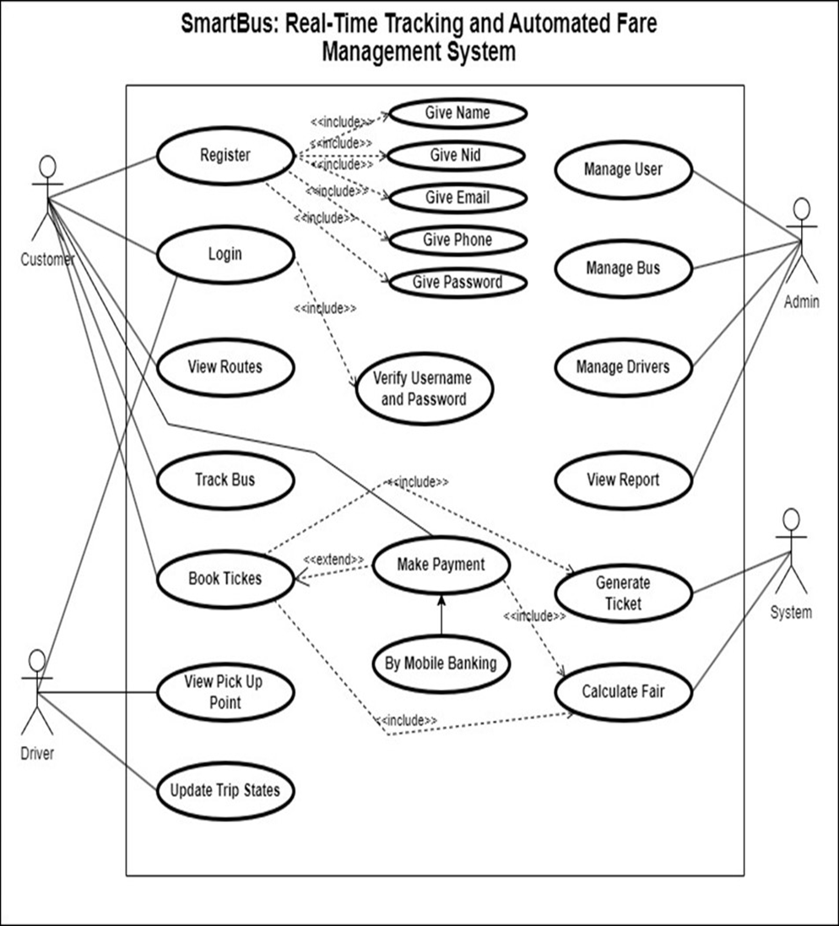

Er Diagram

Class Diagram

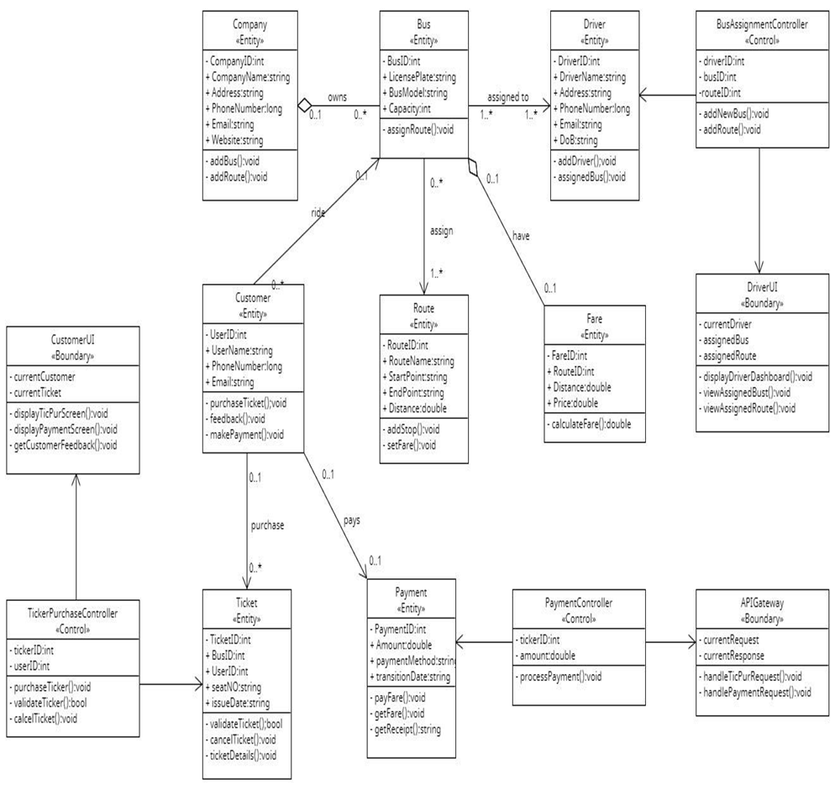

Activity Diagram:
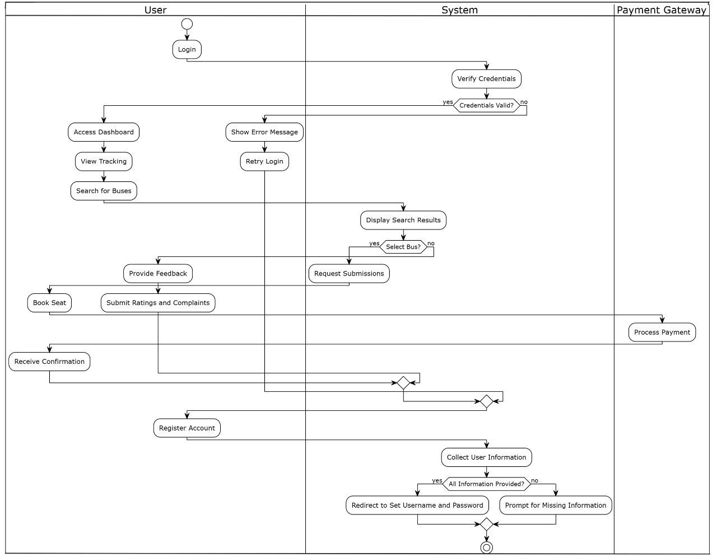

UI Design:

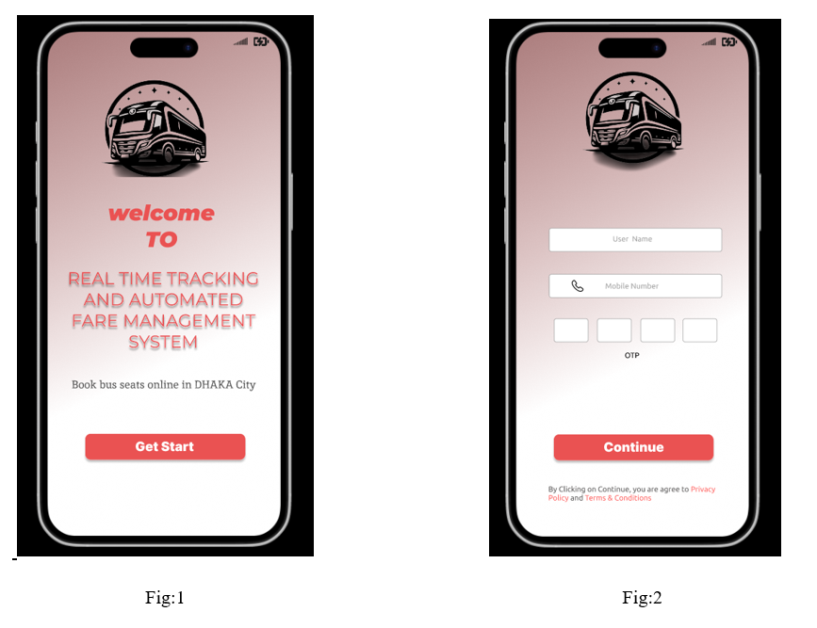

Fig:1

This is the welcome page of the application.

Fig:2

This is the registration page of the application. New users can register to the application through this page by providing full name, username, phone number and unique password.

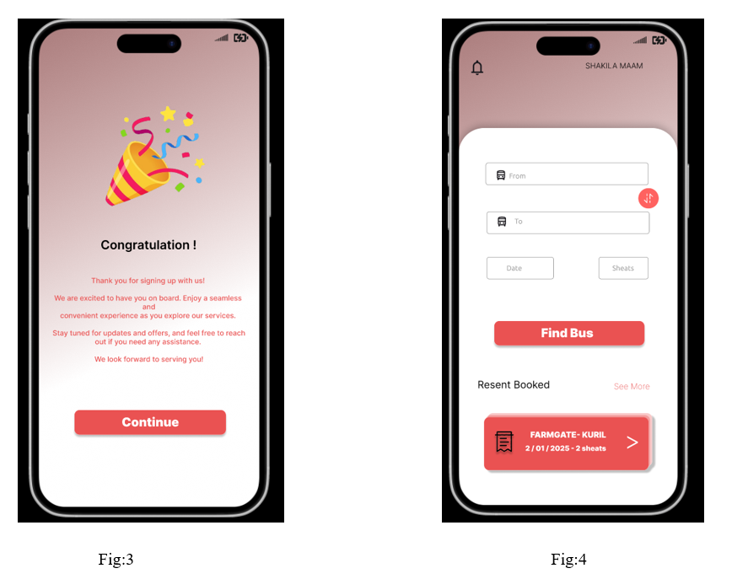
Fig:3
Thank you for coming to the new page by registering for real-time tracking and an automated fare management system.

Fig:4
Search for buses by specifying your departure and destination locations, along with the date and number of seats.

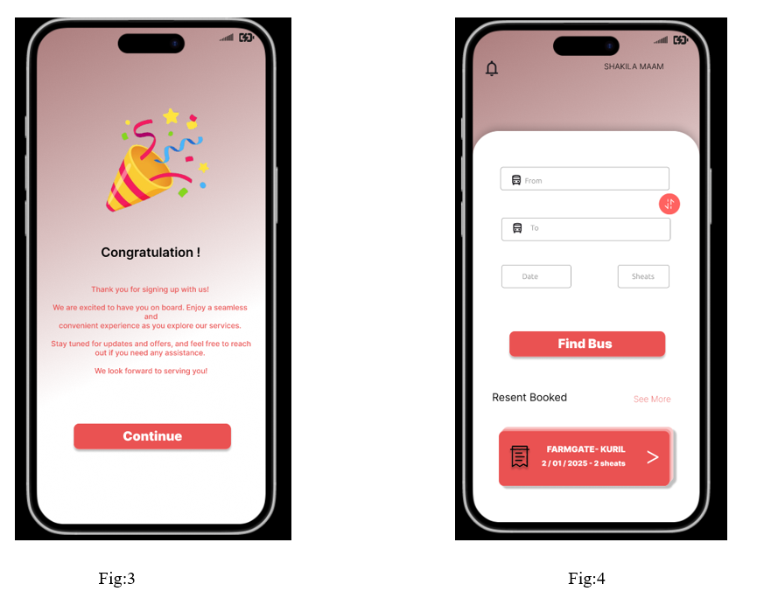
Fig:3
Thank you for coming to the new page by registering for real-time tracking and an automated fare management system.

Fig:4
Search for buses by specifying your departure and destination locations, along with the date and number of seats.

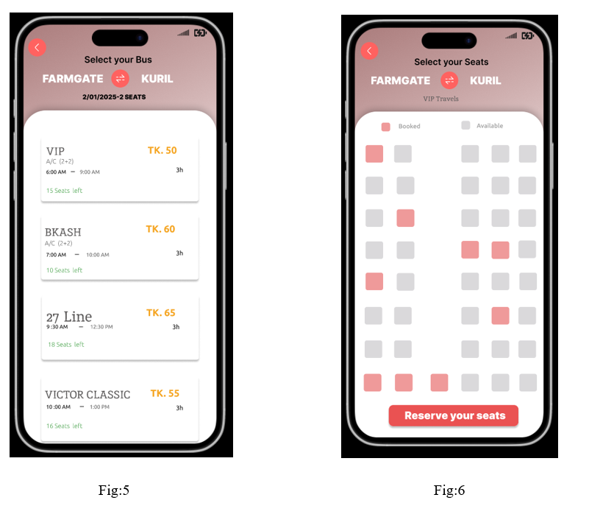
Fig:5

User can choose the bus for long distance. User can see the number of available seat.And also the bus fare. For these bus, user can book the seat .And pay the bus fare through various method.
Fig:6

The user can select their preferred seat from here to reach their destination. Booked seats will be marked in red, and they can select up to two seats at a time.

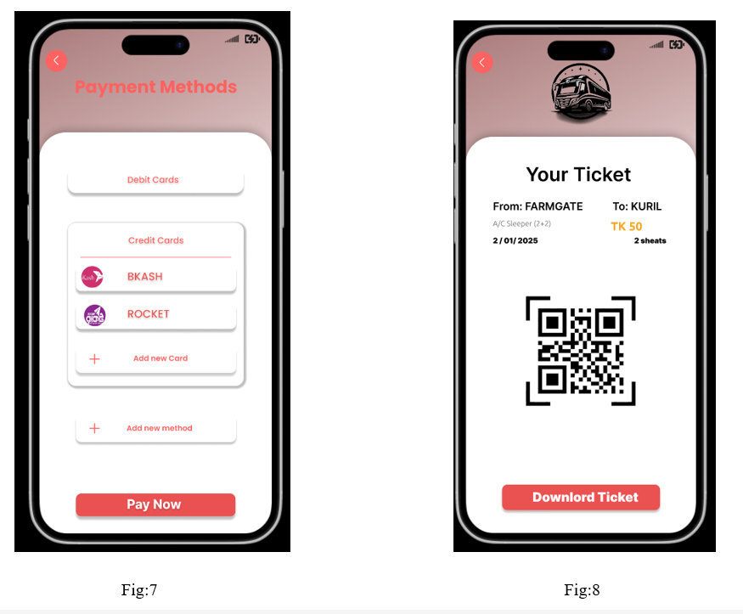
Fig:7
The user can make payments using debit cards, credit cards, and mobile banking systems such as bKash and Rocket. In this interface, the user can also add a new card and a new payment method. Once everything is completed correctly, the payment can be processed.

Fig:8
Once everything is completed correctly, the user will be able to collect their ticket. By clicking the download option, the ticket will be downloaded. The ticket can also be accessed by scanning it with a scanner.

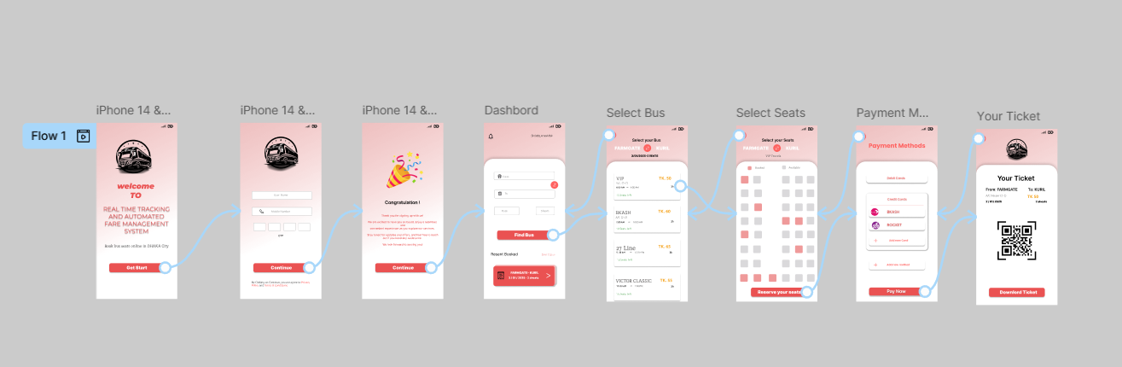
The full prototyping Ui system

